**CH7,9 Task**

1. **Update salaries for employees who work for department 10 with 5000.  
   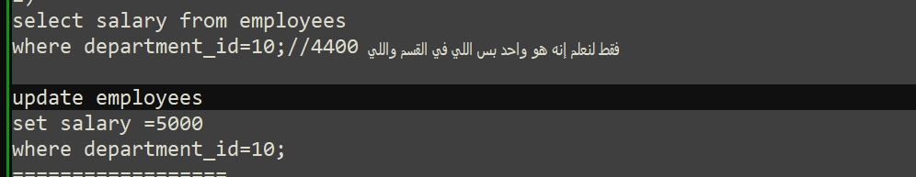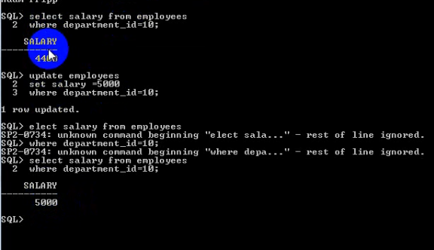**
2. **Update the salary and commission for employee's number 178 such as employee's number 204.  
     
   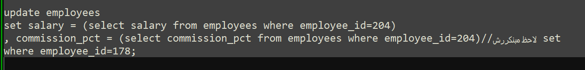  
   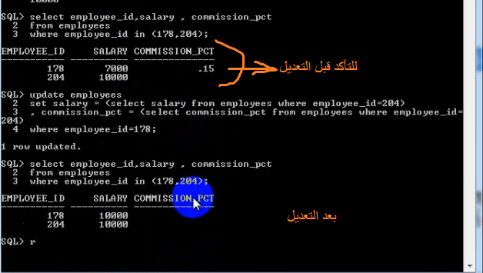**
3. **Add 2-new regions with only one insert statement with data  
    [8-North Africa], [9-South Africa].  
   طالما أكتر من صف هنضيفه يبقى نفتكر ال   
   insert all  
   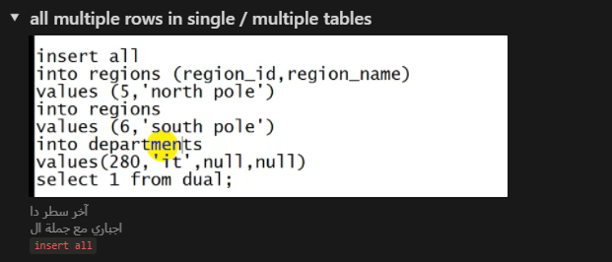  
   before  
   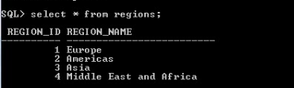  
    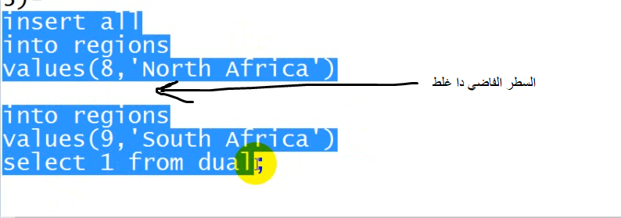  
   شيله وبس  
   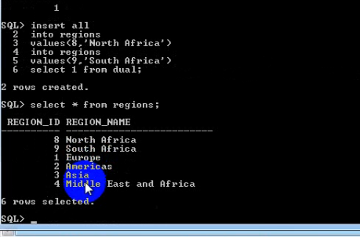**
4. **Delete the two previous inserted rows in regions table.  
   in question 3  
   لو كنت لحقت ممكن تعمل rollback وخلاص  
   وإلا ممكن تعمل  
   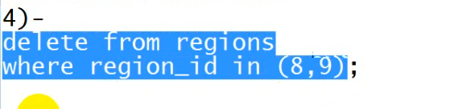  
      
   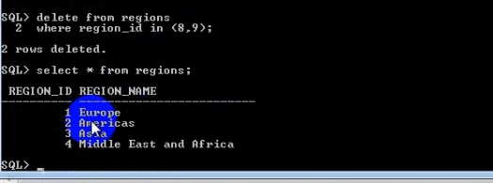**
5. **Display the full name for the employee(s) who earns the highest salary in department 50.  
   